10 Steps to High Quality Java Developer

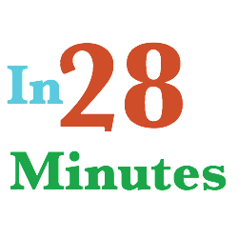

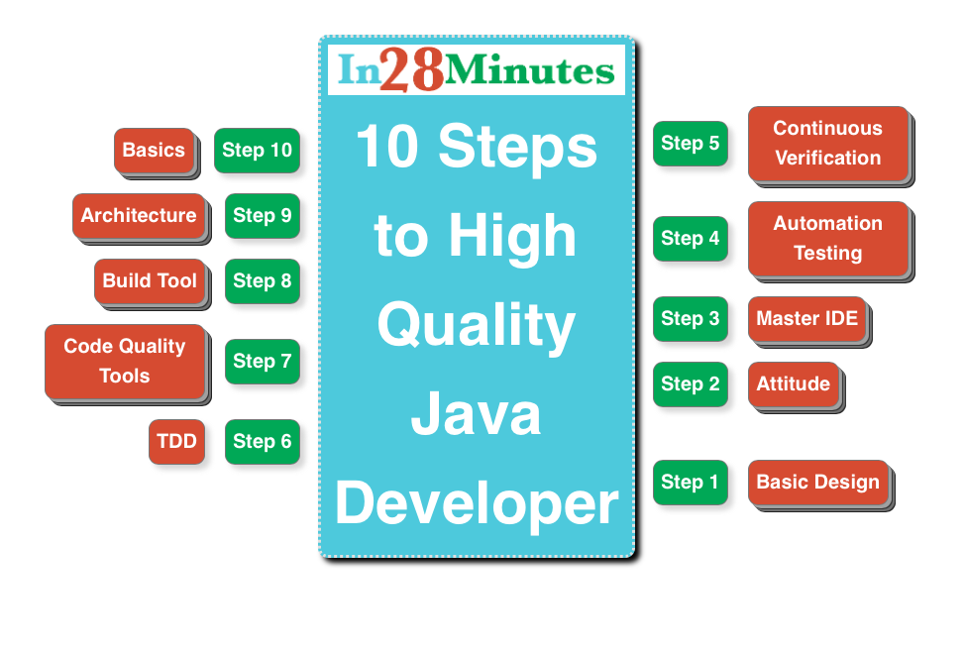

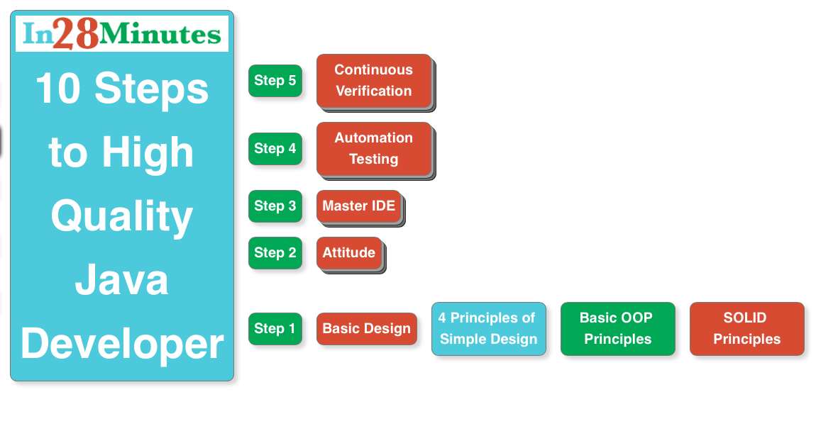

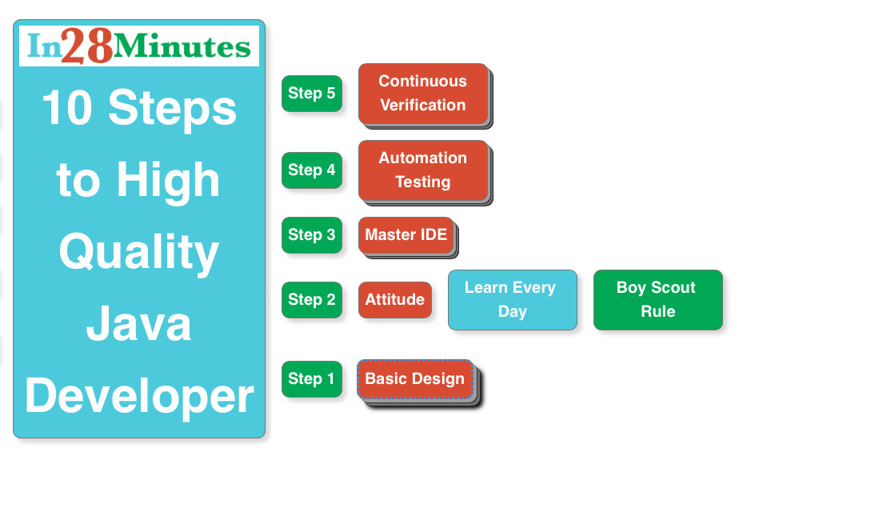

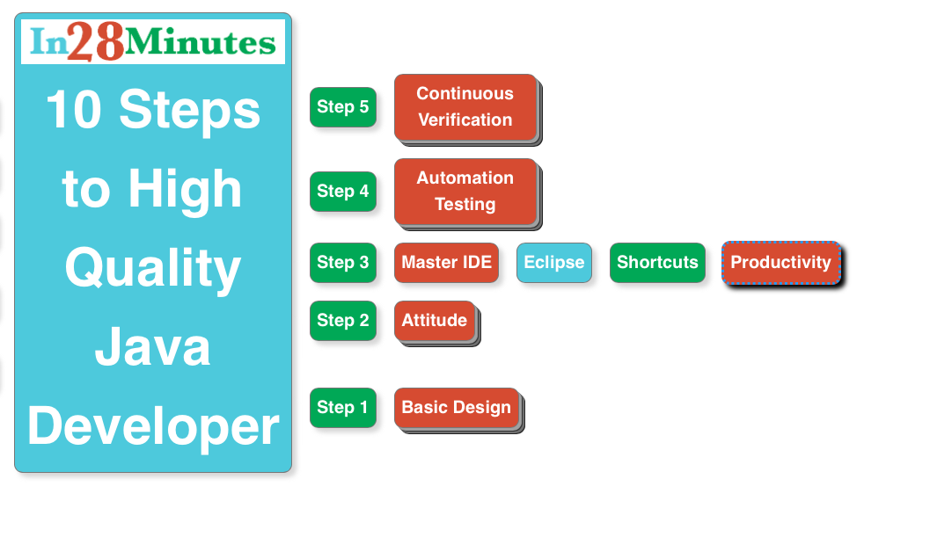

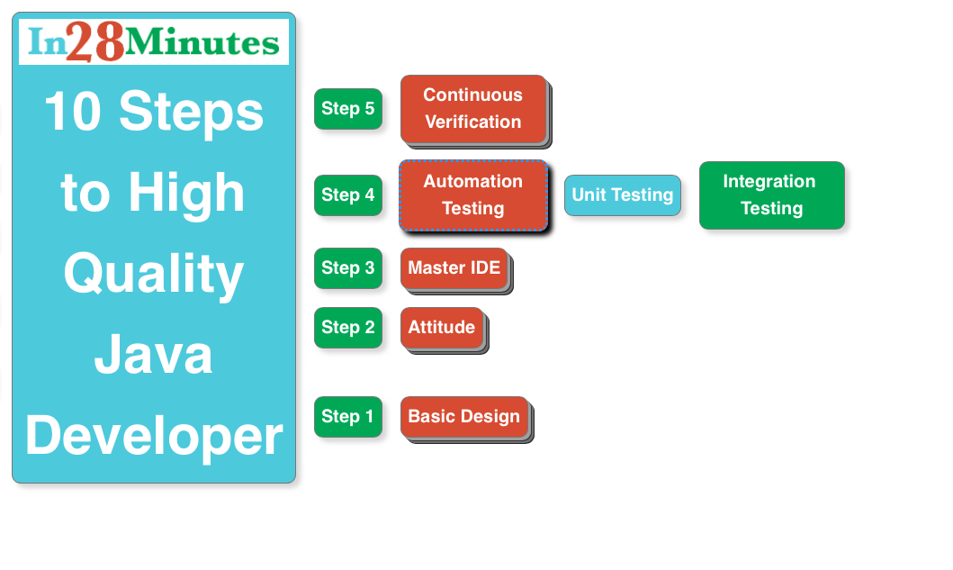

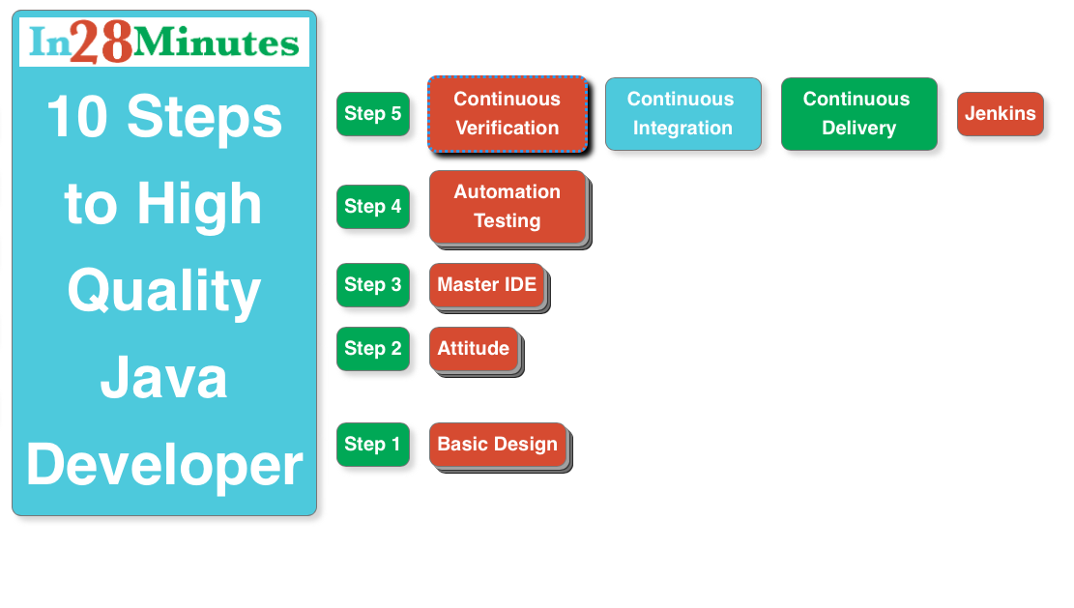

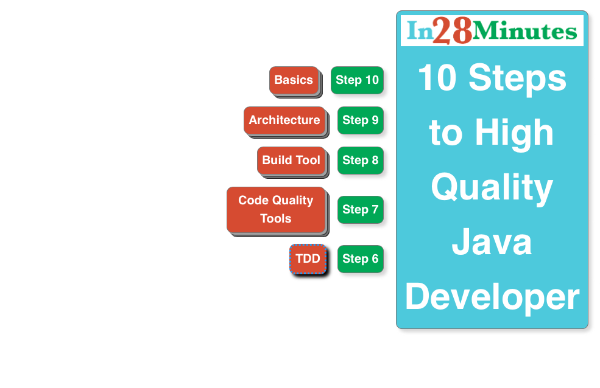

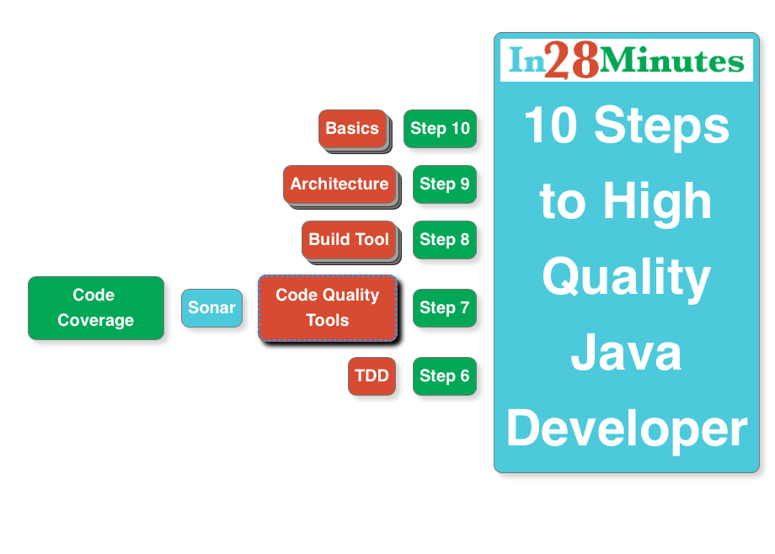

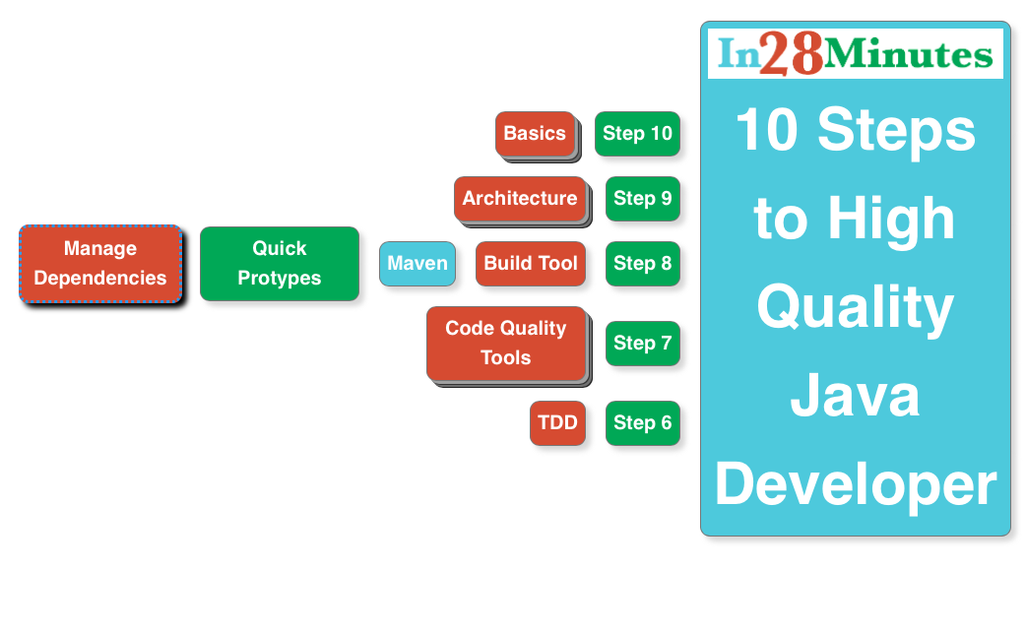

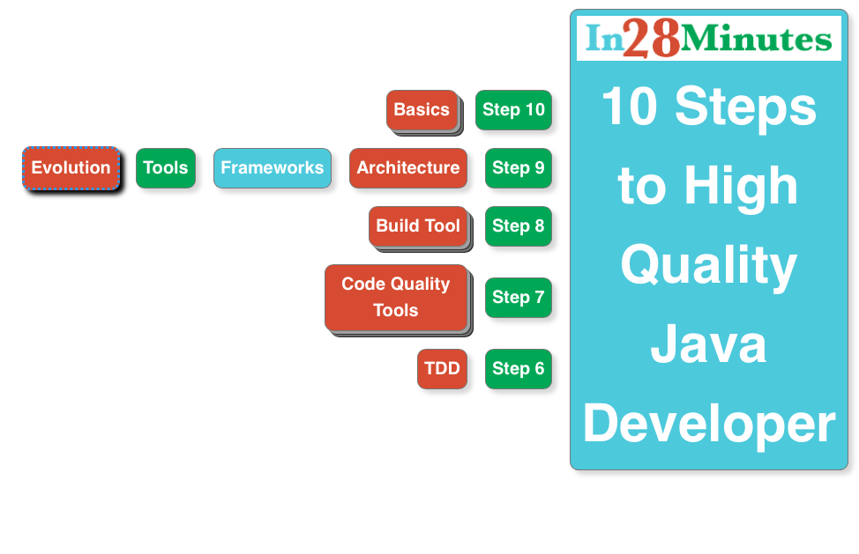

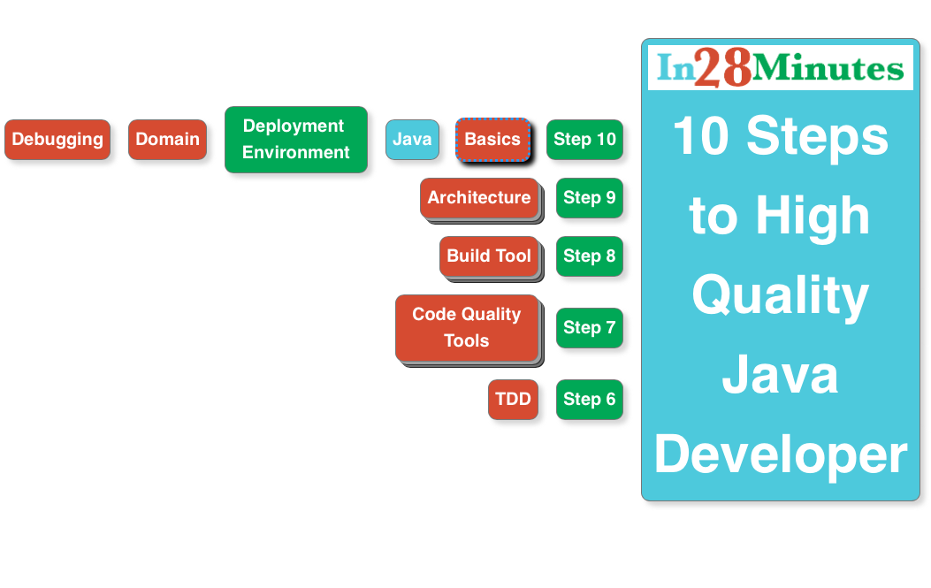

**About in28Minutes**

* At in28Minutes, we ask ourselves one question everyday. How do we help you learn effectively - that is more quickly and retain more of what you have learnt?
* We use Problem-Solution based Step-By-Step Hands-on Approach With Practical, Real World Application Examples.
* Our success on Udemy and Youtube (2 Million Views & 12K Subscribers) speaks volumes about the success of our approach.
* While our primary expertise is on Development, Design & Architecture Java & Related Frameworks (Spring, Struts, Hibernate) we are expanding into the front-end world (Bootstrap, JQuery, Angular JS).

**Our Beliefs**

* Best Courses are interactive and fun.
* Foundations for building high quality applications are best laid down while learning.

**Our Approach**

* Problem Solution based Step by Step Hands-on Learning
* Practical, Real World Application Examples.
* We use 80-20 Rule. We discuss 20% things used 80% of time in depth. We touch upon other things briefly equipping you with enough knowledge to find out more on your own.
* We will be developing a demo application in the course, which could be reused in your projects, saving hours of your effort.
* We love open source and therefore, All our code is open source too and available on Github.

**Useful Links**

* [Our Website](http://www.in28minutes.com/)
* [Youtube Courses](https://www.youtube.com/user/rithustutorials/playlists)
* [Udemy Courses](https://www.udemy.com/user/in28minutes/)
* [Facebook](http://facebook.com/in28minutes)
* [Twitter](http://twitter.com/in28minutes)
* [Google Plus](https://plus.google.com/u/3/110861829188024231119)

**Other Courses**

* [Spring Framework](https://www.udemy.com/spring-tutorial-for-beginners/)
* [Maven](http://www.in28minutes.com/p/maven-tutorial-for-beginners.html)
* [Eclipse](http://www.in28minutes.com/p/eclipse-java-video-tutorial.html)
* Java
  + [Java](https://www.youtube.com/watch?v=Y4ftqcYVh5I&list=PLE0D4634AE2DFA591&index=1)
  + [Java Collections](http://www.in28minutes.com/p/java-collections-framework-video.html)
  + [Java OOPS Concepts](https://www.udemy.com/learn-object-oriented-programming-in-java/)
* [Design Patterns](http://www.in28minutes.com/p/design-patterns-tutorial.html)
* [JUnit](https://www.udemy.com/junit-tutorial-for-beginners-with-java-examples/)
* [C](https://www.udemy.com/c-tutorial-for-beginners-with-puzzles/)
* [C Puzzles](https://www.udemy.com/c-puzzles-for-beginners/)
* [Javascript](https://www.youtube.com/watch?v=6TZdD-FR6CY)
* [More Courses on Udemy](https://www.udemy.com/user/in28minutes/)
  + Java Servlets and JSP : Your first web application in 25 Steps
  + Learn Spring MVC in 25 Steps
  + Learn Struts in 25 Steps
  + Learn Hibernate in 25 Steps
  + 10 Steps to Professional Java Developer